ULTRASONIC TESTING REPORT
Company/Client |  | NCOC N. V. |  | Project |  | ESKENE WEST |  | Location |  | Workshop
Line No/Tag No: |  | M2-5300-DW-058-3-A05-HC |  | Material |  | A312 Gr. TP316/316L |  | Día × Nominal Thickness |  | 3”×3.05mm
Procedure No: |  | QP-11-UTT-Q01 Rev 03  GOST 28702-90 |  | Calibration Block |  | Step wedge |  | Probe  S/N |  | D7908  1214564
 |  |  |  | Calibration block Range |  | 2.5-12.5 mm |  | Angle |  | 0º
Manufacturing Code |  | ASME B31.3 |  | Calibration Temp |  | +8º |  | Frequency |  | 7.5 MHz
 |  |  |  | Object Temp |  | +5º |  | Size |  | 5.1 mm
Acceptance Standard: |  | Acc. to the client specif. |  | Correction factors |  | n/a |  | Crystal |  | Dual
Surface condition |  | Coated |  | Couplant |  | UT Gel |  | Accuracy |  | ± 0,1 mm
S. No | Equipment/  Material Name |  | Manufacturer |  | Serial No |  | Calibration certificate No |  | Calibration Expiry date
 | A-scan UT |  | OLYMPUS DL-38 |  | 171421601 |  | 2113237 |  | 02.04.2020
 | Step wedge calibration block |  | OLYMPUS |  | 026519 |  | - |  | -
Job description:

- UT spot check performed on line M2-5300-DW-058-3-A05-HC (drawing TR01-M2-530-WK-P-DI-0011-001)
- Inspection performed on South, North, Top, Bottom
- Echo-to-echo UT technique was used.

Notes:
N/A – not applicable.
FSH - Full Screen Height

Inspection drawing
TR01-M2-530-WK-P-DI-0011-001
M2-5300-DW-058-3-A05-HC
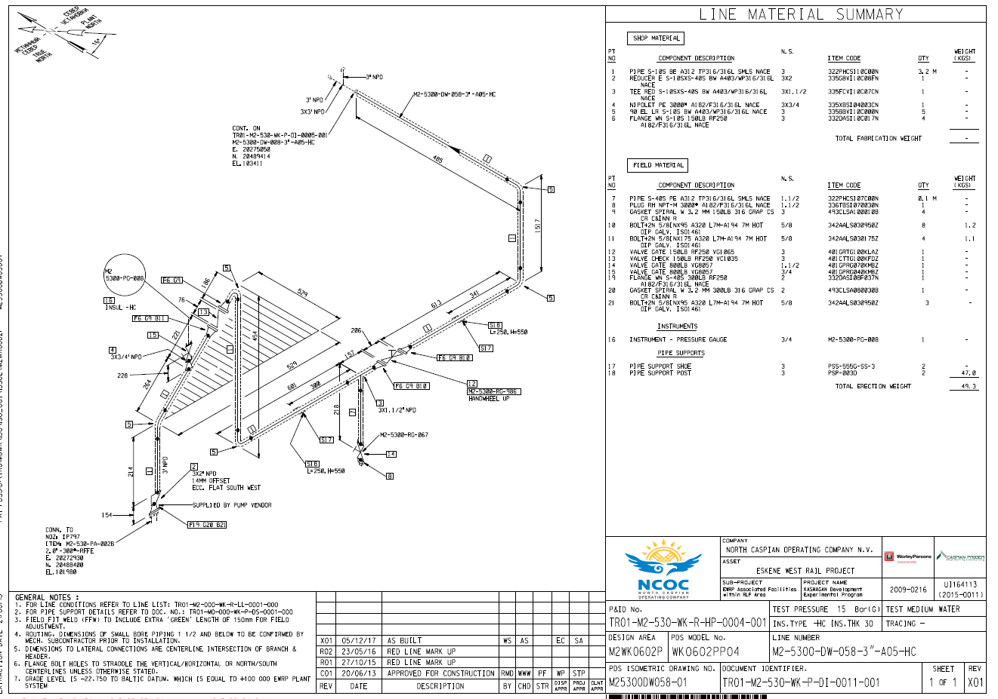
UT spot check

S/NO | Line No | Item description | DIA(Ø), inch | Nominal thickness, mm | South  mm | North  mm | Top  mm | Bottom  mm
1 | M2-5300-DW-058-3-A05-HC  TR01-M2-530-WK-P-DI-0011-001 | Tee | 3’’ | 3.05 | 7.55 | 7.65 | 7.59 | 7.37

Examined by  UT L II cert. No 048  expiry date: 01.03.2020 | Name: Kosmukhambetov Rustembek | Signature:............................... | Date: 25 November 2019
Approved by  UT L III cert. No 2B 189/16  expiry date 31.05.2021 | Name: Klindukhou Viachaslau | Signature: ............................ | Date: 25 November 2019
Client Representative: | Name: …………………………… | Signature: .............................. | Date: ………………………

